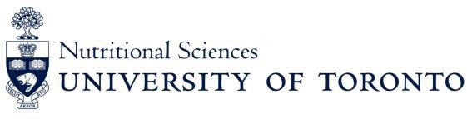
2024 Application Form Undergraduate Summer Research Opportunity Program (UROP)

APPLICATION DEADLINE: Friday, February 23, 2024
Please submit this completed application with all documentation to the Nutritional Sciences Undergraduate Program Administrator by email to dns.admin@utoronto.ca.
Eligibility: Must have at least a B+ (GPA of 3.3) average or higher and are responsible for securing a position with a Nutritional Sciences supervisor; interest in future graduate training; available to work for a minimum of 12 weeks (dates to be determined between you and your supervisor); must attend weekly seminars and participate in the mini-conference generally held the first week of August.

Last Name: | First Name:
Email: | Telephone:
Address:
Current University: | Student Number:
Program of Study:  Specialist:  Major:  Minor: | Current Year of Study:
List of Relevant Life Sciences & Lab Courses (E.g., NFS, CHM, BCH, PSL, etc.)

Statement of Research Interest and Future Goals

Previous Research/Work Experience

Please rank your prospective supervisor in order of preference:
1. 2. 3. 4. Student Signature: ______________ _____Date:
Please attach your cover letter, CV/resume, a copy of your grades from ACORN or most recent transcrip. A reference letter on your behalf from a Professor or previous employer should be sent directly by email to dns.admin@utoronto.ca and addressed to Dr. Ahmed El-Sohemy, Summer Research Coordinator. In the subject of the email, please use the 2024 Undergraduate Summer Research Opportunity Program.

